

WEEKLY MEETING NOTES

STUDY 2



Schol of mathematical sciences, queensland university of technology

**Objective of study 2**

Develop designs which will be efficient across empirical, complex and mechanistic models for coral cover prediction in the future.

**Study plan**

* Define model space
* Beta regression with coral growth component (Gomprtz model)
* Bayesian semi parametric hierarchical model (Vercelloni et al., 2014)
* Generalized linear mixed models
* Estimate posterior of each model using Laplace approximation
* Develop a model discrimination utility
* Find design which will be efficient across empirical, complex and mechanistic models

**Challenges:**

* Implement models using Laplace approximation
* Computational time model discrimination utility

**Timeline**

|  |  |  |  |  |  |
| --- | --- | --- | --- | --- | --- |
| September | October | November | December | January | February |
| Gomprtz model | | Bayesian semi parametric hierarchical model+ Generalized linear mixed models | | Model discrimination utility/ Find design | Draft a chapter based on study 2 findings |

**Publication**: Improving the accuracy of coral cover prediction in the future considering model uncertainty

**Target journals:** Coral Reefs, Biological Conservation, Marine and Freshwater Research.

|  |
| --- |
| Date of Meeting: 2018/08/24 |

## Discuss weekly progress:

* Literature review on Coral growth, Gomprtz model,Bayes estimation
* Working on addressing feedback for paper 1

## Issues for discussion:

* Coral growth on the GBR
* Acroporidae and other hard coral proportions
* Design space; Whitsunday or another sector
* Get MMP data

## Other scholarly activities:

* Session 1: Authorship and Publication Seminar @ Mon Aug 20, 2018 1pm - 3:30pm.
* Susan Murphy-2018 AMSI SSA Lecture at QUT

## Work set for the next meeting:

* Familiarize with MMP data
* Implement Gompertz model for MMP data

## Supervisor(s) present:

Dr. Erin

Dr. James

Dr. Chris

|  |
| --- |
| Discussion |

Hard coral cover is explained not only by a set of predictor variables in a linear way but also by a model that would include a temporal coral growth component.

g(HC)  ~ m(HC) - [COTS +  cyclones ...] + [...] where g() would be a link function and m() would be  coral growth over time when no disturbances are present.

 m()-exponential differential equations which

Gompertz model

would model coral growth over time

1. We need hard coral growth rate during inter-disturbance period.
2. The intensity and frequency of combined disturbances should be considered when assessing the status of an observed coral community.
3. The consideration of status should also include the capacity of a community to recover during periods free from disturbance.
4. This requires a modelling approach that integrates recovery rates and disturbance regimes to generalize from a specific sequence of events to a more general case.

**Coral growth on the GBR**

* Patterns in coral reefs range from the small-scale architecture of a particular colony to large-scale reef distribution patterns.
* Many complex factors that can contribute to the development of these patterns.
* E.g. Influence of **ocean currents** appears to affect coral reef orientation over many scales, **water quality**, **nutrient supply** and so on.
* Same species can exhibit different growth forms under different flow regimes.
* It is evident that the ambient environmental conditions profoundly influence morphology.

It is required to map habitats for the Gompertz models. Dr. Patricia said that there is no habitat map done that would cover the entire GBG. Any source to find habitat maps?

Corals grow differently in different region (Inshore, mid, outer). I found Gompertz models only for the inshore reef. Are there Gompertz models for other regions? Are we going to only focus on inshore?

|  |  |
| --- | --- |
| **A disturbance period** | **A period of undisturbed growth** |
| Years in which disturbance events occurred at particular reefs preclude the estimation of this indicator as there is no expectation for increase in such situations. | Gompertz equations were parameterised separately for the fast growing corals of the family 9 and the slower growing combined grouping of all other hard corals. |

**How to get Acroporidae and other hard coral values at given time t?**

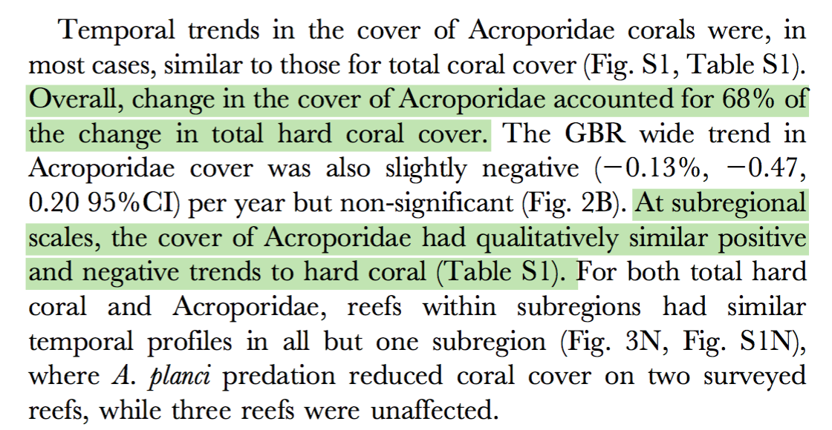



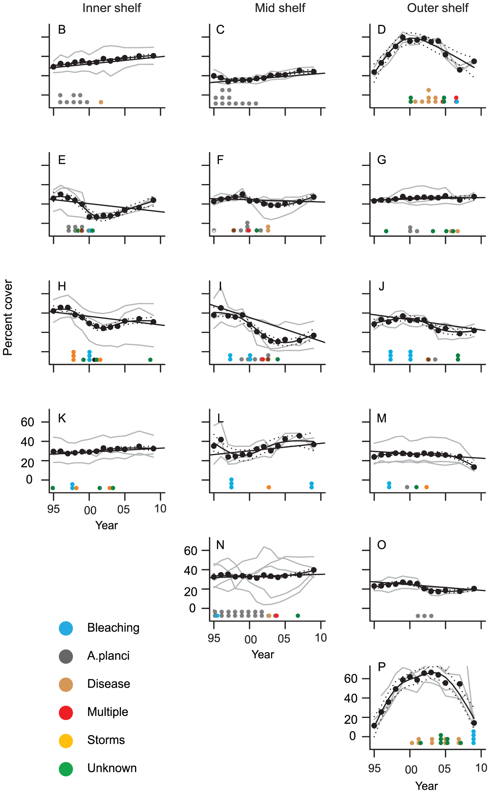

**Gompertz models**

Some of the coral species grow at different rates. The resulting growth equations were:

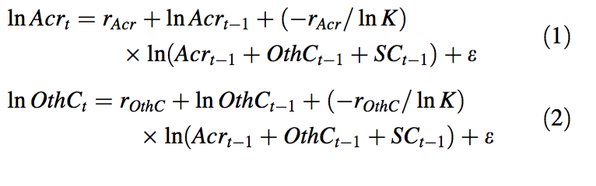

*SCt-1* not required.

Acrt- the cover at time t of Acroporidae

OthCt -the cover at time t of other hard coral

rAcr-the rate of increase in percent cover of Acroporidae (growth rate)

K -the equilibrium community size (100 here)

the random error term that accounts for low-level or background levels of disturbance that appear in the data as minor losses of coral cover to which it was impossible to attribute a cause.

**Estimate growth rates:**

* Growth rates of Acroporidae and other hard coral were estimated by fitting Eqs. 1–2 to data for reef-years in which no major disturbance event occurred.
* Equations 1–2 are fit as a nonlinear mixed effects models with the R package NLME.
* Use random effects for the growth rate parameters (random intercepts) at reefs nested into latitudinal regions to improve the accuracy of the estimates by accounting for repeated measurements at individual reefs and the unequal numbers of observations at different reefs and in different latitudinal regions.

These estimated growth rates were then used to predict expected change in cover for years where disturbance did occur but assuming there had been no disturbance.

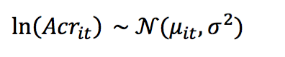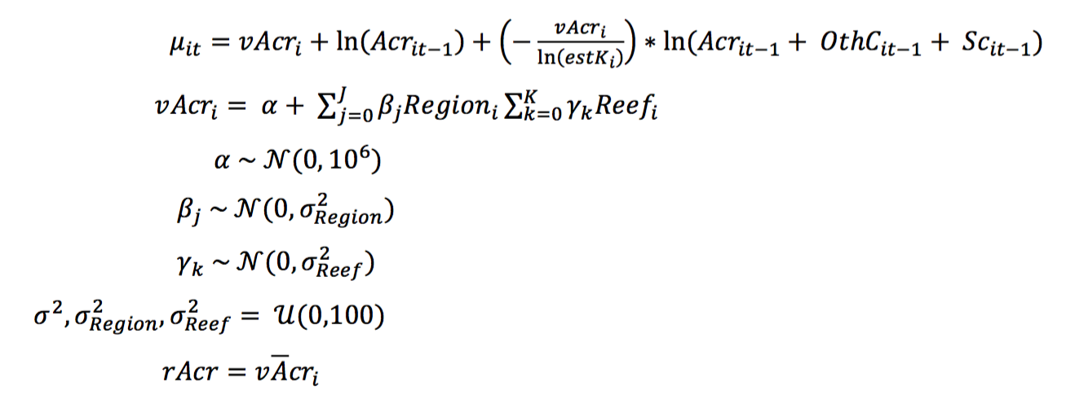

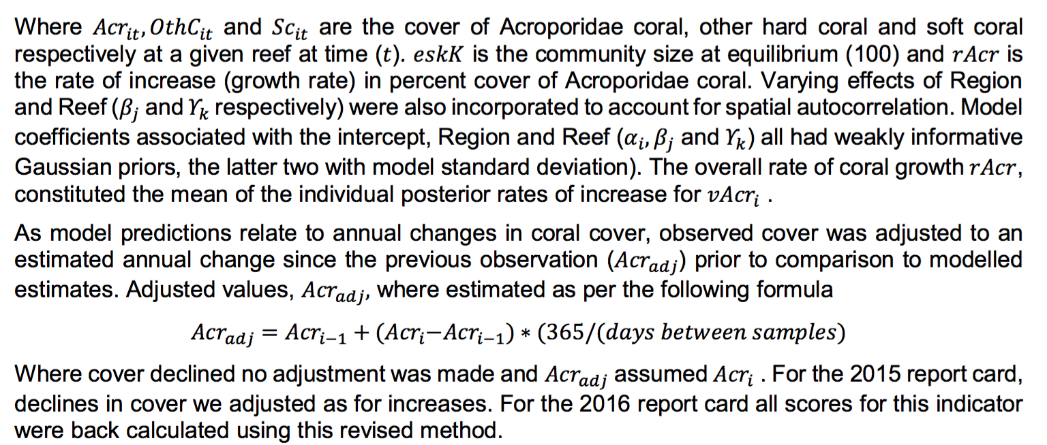

|  |
| --- |
| Date of Meeting: 2018/08/31 |

## Discuss weekly progress:

* Literature review on Gomprtz model, benthic community, etc.
* Working on addressing feedback for paper 1

## Issues for discussion:

* Are we going to consider coral disease disturbance/water quality?
* Selecting a sector on GBR (Whitsunday?)
* Hard coral only or Acroporidae +other hard coral
* Creating a new benthic community map for selected sector or use already available map for whole GBR

## Other scholarly activities:

* Attending BRAG meeting
* Acroporidae

## Work set for the next meeting:

* Implement Gompertz model

## Supervisor(s) present:

Dr. James

Dr. Erin

Dr. Chris

|  |
| --- |
| Discussion |

**Mellin c, et al. (in review) Bright spots of coral resilience on the Great Barrier Reef.**

They used the mechanistic, Gompertz-based model of coral growth fitted to the LTMP reefs by MacNeil et al. (14) to **reconstruct coral cover** trajectories over the last 20 years (1996-2015) for every 0.01° grid cell.

**MacNeil MA*, et al.* (in review) Decline and recovery of the Great Barrier Reef. *Proceedings of the National Academy of Sciences*.**

The natural logarithm of hard coral cover () as follows:

(Eq. 1)

where is the intrinsic growth rate, is proxy for average water turbidity (defined as the frequency of primary, secondary and tertiary river plumes during the 2007-2013 wet seasons and its effect size,  **is the density dependent growth rate**, and is the effect size of the ith disturbance occurring in year *t* (; *i.e.* bleaching, *A. planci* outbreak, **disease**, cyclone or unknown).

They used the effect size estimates () determined by MacNeil et al. (see Table below for a summary of model parameters, sources and values).

**Table 1.** Gompertz model parameters: source, description, mean and standard deviation.

|  |  |  |  |  |  |
| --- | --- | --- | --- | --- | --- |
| Code | Variable | Unit | Source | Mean | Standard deviation |
| HCini | Initial coral cover | % | BRT | 34.58 | 0.24 |
| HCmax | Maximum coral cover | % | BRT | 40.70 | 0.41 |
|  | Coral intrinsic growth rate | - | MacNeil et al. | 1.06 | 0.46 |
|  | Disturbance effect sizes | - | MacNeil et al. |  |  |
|  | * Bleaching |  |  | -0.19 | 0.01 |
|  | * *A. planci* outbreaks |  |  | -0.54 | 0.04 |
|  | * Cyclones |  |  | -0.64 | 0.01 |
|  | * Disease |  |  | -0.13 | 0.01 |
|  | * Unknown |  |  | -0.16 | 0.01 |
|  | Water quality effect size | - | MacNeil et al. | -0.68 | 0.03 |

Each of these parameters were estimated for the 46 reefs surveyed by the LTMP.

In our case, we need to choose a particular region on the GBR to avoid computational complexity.

So, we can’t use these estimates directly.

**MacNeil MA*, et al.* (in review)** is an adaptation of the Gompertz-based model of benthic covers developed by Fukaya et al.

**Fukaya K, Okuda T, Nakaoka M, Hori M, & Noda T (2010) Seasonality in the strength and spatial scale of processes determining intertidal barnacle population growth. *Journal of Animal Ecology* 79(6):1270-1279.**

A **barnacle** is a type of [arthropod](https://en.wikipedia.org/wiki/Arthropod) constituting the [infraclass](https://en.wikipedia.org/wiki/Infraclass) **Cirripedia** in the subphylum [Crustacea](https://en.wikipedia.org/wiki/Crustacean), and is hence related to [crabs](https://en.wikipedia.org/wiki/Crab) and [lobsters](https://en.wikipedia.org/wiki/Lobster).

**Four shores**

v

v

v

v

**Census plot (500cm2) on the rock walls in semi-exposed locations**

They defined **three spatial scales** corresponding to the three hierarchical levels of the census design: **regional scale**, corresponding to the entire study area (i.e. tens of kilometres); **shore scale**, within a single shore (hundreds of metres); and **rock scale**, a single census plot (tens of centimetres).

Coverage of *C. challengeri* was measured at each plot twice a year.

The occurrence of *C. challengeri* at 200 points on a grid with 5-cm intervals in both vertical and horizontal directions was recorded.

They applied a state-space model, composed of a **process model** representing the underlying population dynamics and a **data model** incorporating observation error.

In the **process model**, the population growth rate of *C. challengeri* was decomposed into several **density-dependent** or **density-independent** components.

**density-dependent**

* the strength of the density dependence (the change in the population growth rate in relation to the population size).

**density-independent**

* the intrinsic growth rate (the temporally averaged density-independent growth rate)
* the density-independent stochastic fluctuations of growth rate at regional, shore and rock scales

**Population dynamics** of C. challengeri in each plot was modelled at the **rock level**; spatial variability in intrinsic growth rate and the strength of density dependence within each shore were modelled at the shore level; and the spatial variation in intrinsic growth rate and strength of density dependence among shores were modelled at the regional level.

In the data model, frequency of C. challengeri in each plot was assumed to follow a binomial distribution.

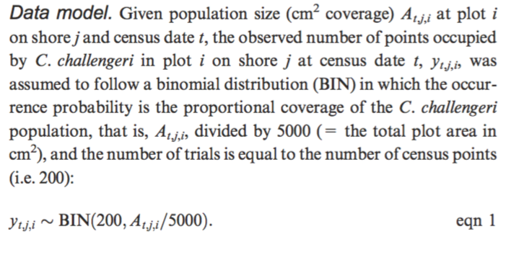

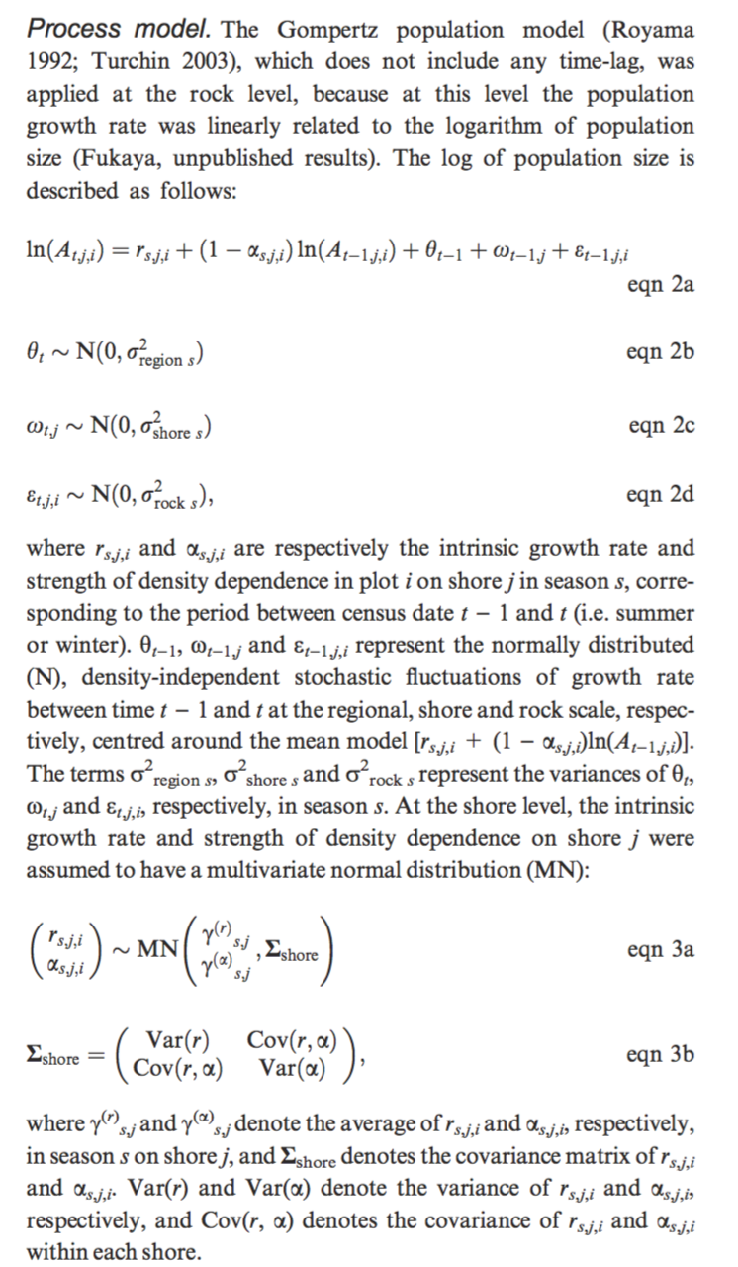

***Characterization of benthic communities across the GBR***

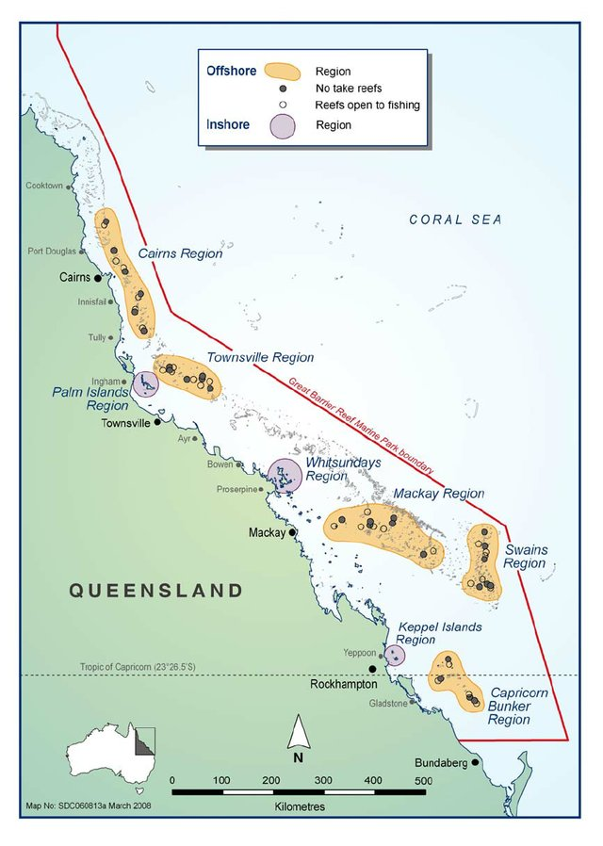

Determined clusters of reefs of similar benthic composition and tested whether similar coral assemblages have more **similar intrinsic growth rates** than dissimilar assemblages.

We used multivariate regression trees (MRT) (23) to model the relationship between spatial and environmental covariates and the relative cover of the different benthic groups and coral growth shapes.

MRT forms clusters of sites by repeated splitting of the data, with each split determined by habitat characteristics and corresponding to a distinct species assemblage.

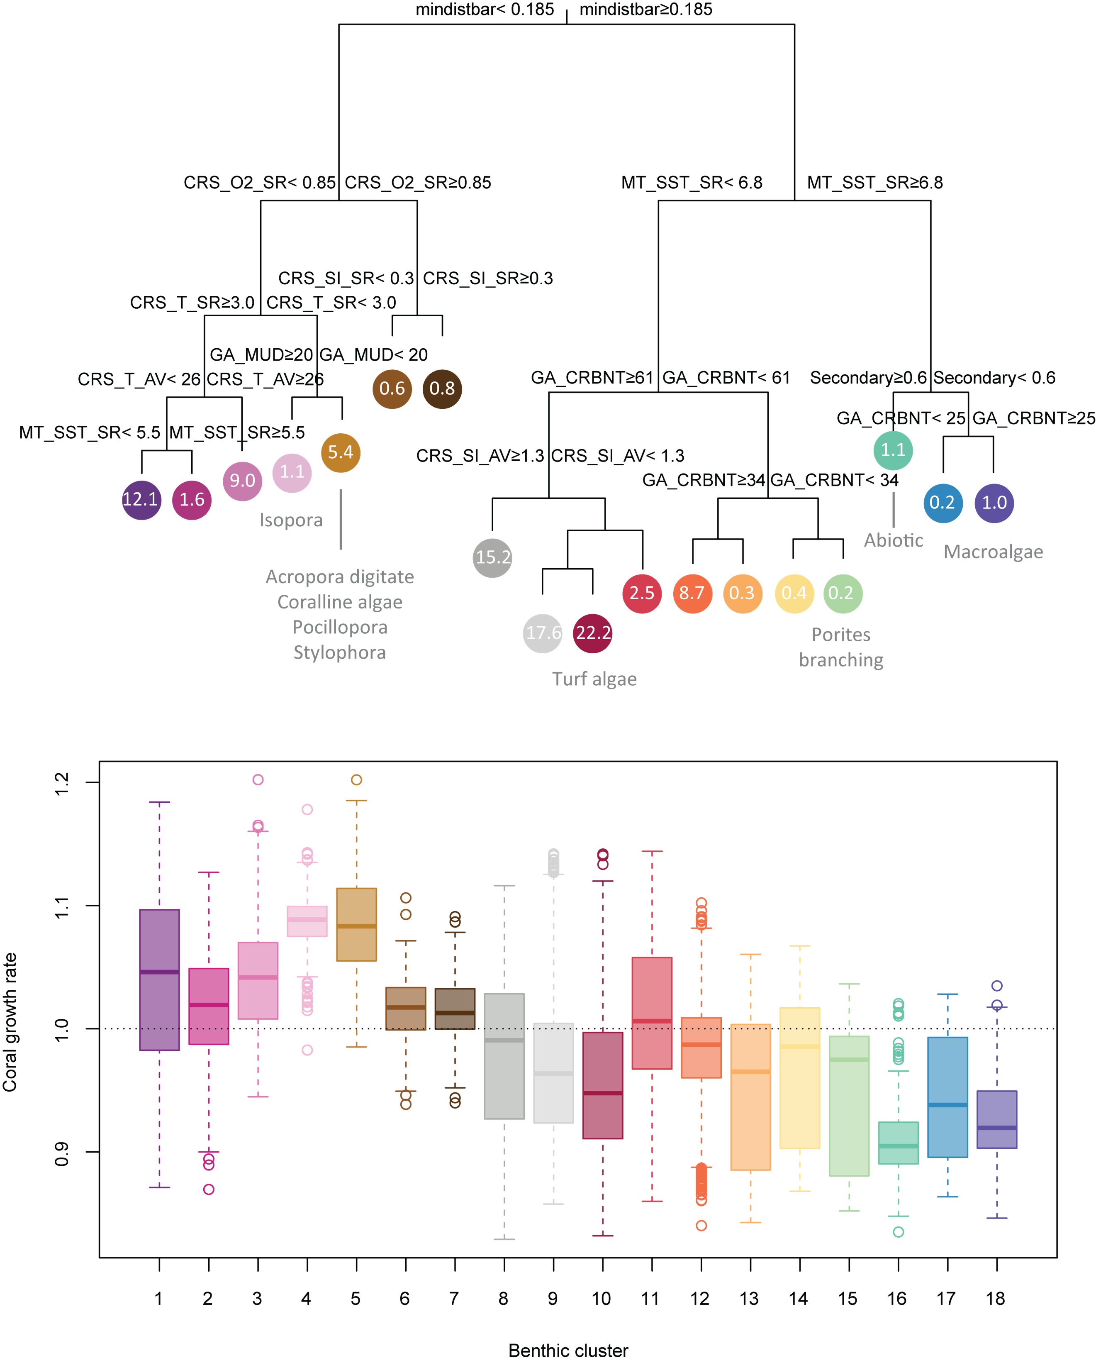

Figure S3. Multivariate regression tree predicting benthic community composition as a function of environmental and spatial variables on the Great Barrier Reef. **Top panel**: **a total of 15 benthic communities were defined by splitting all samples (N = 46) based on environmental predictors (only the most important predictors are shown for clarity; see Table S1 for variable codes)**. Indicated are the proportion of each community on the GBR (%) and, where applicable, indicator taxa identified based on the Dufrêne-Legendre index. **Bottom panel**: **coral intrinsic growth rates () predicted by BRT for each community**. The thick line indicates the median, hinges the interquartile range, whiskers the 90% confidence interval and dots show outliers.

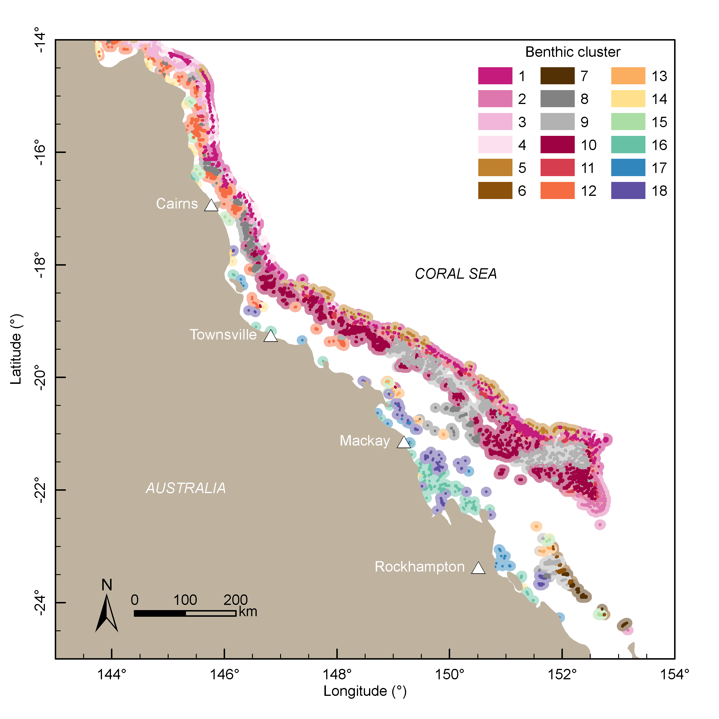

Figure S4 Benthic clusters predicted across the Great Barrier Reef by multivariate regression trees. See Fig. S3 for environmental variables, indicator taxa and coral growth rate associated with each cluster.